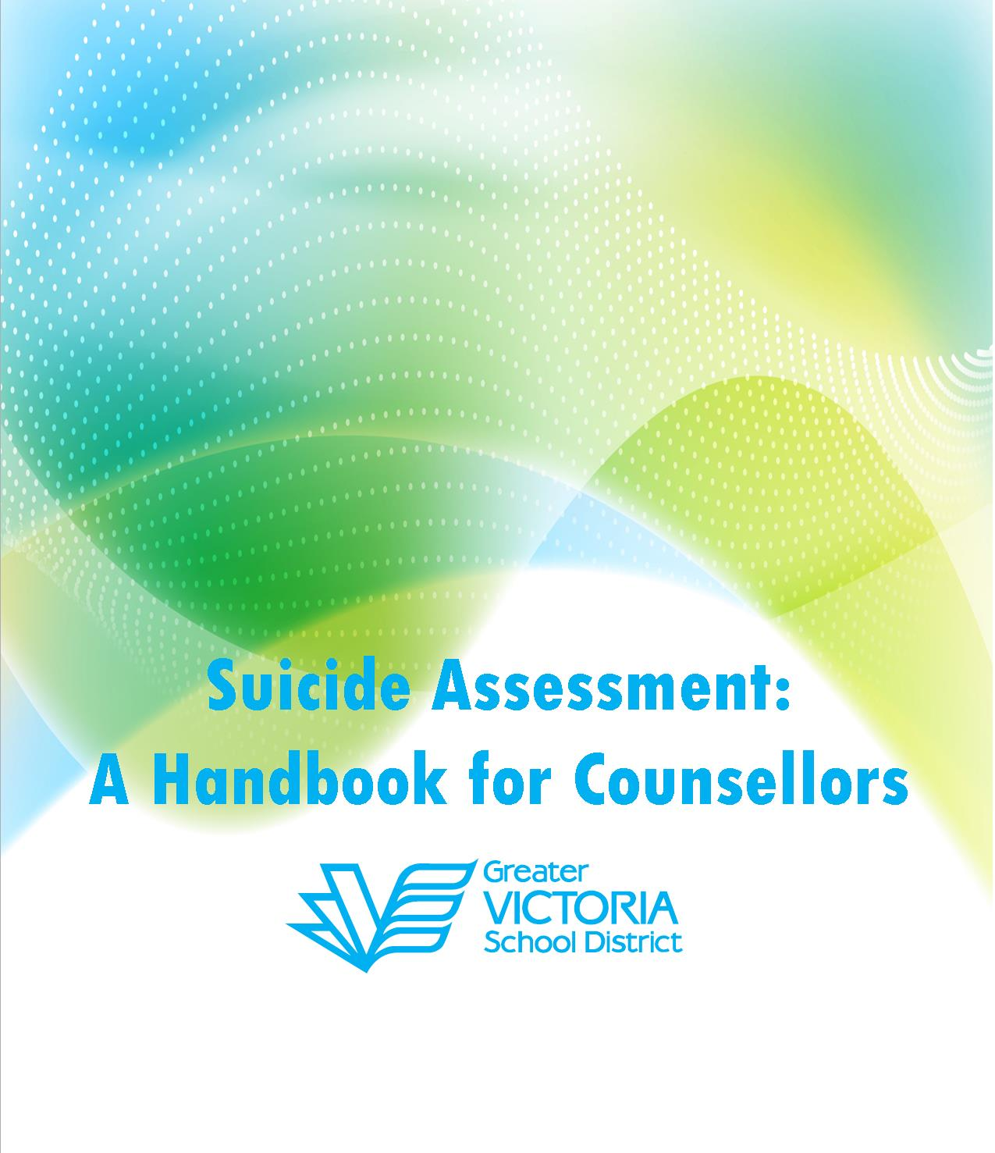
Greater Victoria School District Mental Health Team 2023
SPECIAL THANKS TO:

ORIGINAL DOCUMENT 2018:
- Community Link
- Greater Victoria Local Action Team
- Island Health: Susie Girling & Mike Kinch
- CYMH High Risk Team
- Need2: Justine Thompson
- Dr. M. K. Nixon
- Deanna Skinner

UPDATED DOCUMENT 2021:
  - Lisa Clarabut
  - High Risk Team
  - CYMH Mental Health Team

UPDATED DOCUMENT 2023:
- School District 61 Mental Health Team

Guidelines for Using Suicide Ideation Protocols

- The 3 step Ideation Protocol is a tool for counsellors and shouldn’t be given to the student or family to complete.
- Screening tools are the tools currently being used most often by CYMH and Island Health - they are examples and there are certainly other tools available.
- Hospital admission is most often based on a youth both identifying a strong wish to die AND that they have a clear plan in place.
- It is imperative that counsellors consult when assessing risk for suicide: other counsellors, ER nurses, and/or IMCRT are all good sources
- A plan for staying safe needs to be an ongoing document and conversation - it should be revisited regularly
- If a student engages in multiple suicide attempts, please consult with District Counsellors to consider completing a Violent Threat Risk Assessment (VTRA).
- High Risk Team is not an emergency, crisis resource
- All sheets in this binder can be considered masters and you are welcome to photocopy. However, the resources in this binder are to augment other training around suicide assessment and should not be used by non -counsellors.

All handouts are developed for School District 61Counsellors and can be copied for the support of students in their care.

Table of Contents
Guidelines for Using Suicide Ideation Protocols 2
Section 1: Suicide Protocol 4
Three Step Response for Suicidal Ideation 5
Screening Tools 6
Tool for Assessment of Suicide Risk: Adolescent Version (Tasr-A) 7
SAD Persons Scale 8
S.L.A.P. – Degree Of Intention 9
HLP Process For Assessing Suicide Risk 10
The H*L*P Process Screening Tool 11
Is Path Warm? – Screening Tool 12
6-ITEM Kutcher Adolescent Depression Scale: KADS 13
Section 2: Safety Plans 15
Safety Plan #1 16
Coping Plan 18
Safety Plan #2 19
Section 3: Resources 20
Community Phone Numbers 21
District Contacts 22
Resources for Youth & Families 23
Articles, Toolkits & General Resources 25
Current Self - Report of Suicide Risk 26
Hope Boxes 27
District Suicide Threat Protocol 29
Resources for Younger Students 33
My Safety Plan 34
Visual Mood Scale 35
Visual Mood Scale (With Number Scale) 36
Resources for Students with Indigenous Ancestry 37

Section 1: Suicide Protocol

Three Step Response for Suicidal Ideation

STEP 1: STUDENT INFORMATION:

Name: Age: Pronouns: DOB:
Youth Cell: Youth Email:
Address:
Guardian(s) Name:
Guardian(s) Phone/Cell:
Address if different than above:
Grounds for concern, including any statements made or information provided:

STEP 2: SUICIDE RISK ASSESSMENT:

- Complete Risk Assessment (see screening tools section and select one)
- Ask questions for risk to others. Is student a risk to others? If, so consult with Principal and/or District Counsellor(s) about potential VTRA (Violent Threat Risk Assessment).
- Assess level of risk:
  - No Risk (Consult with Counselling colleague, and if elementary, also School Administrator and Parent/Guardian) Student Support Plan may not be safety plan.
  - Low Risk (Consult with Counselling colleague and School Administrator) Complete Step 3 with check – in within week.
  - Medium Risk (Consult with Counselling Colleague, School Administrator and potentially outside agency (IMCRT, ER Nurse, High Risk Team) Complete Step 3 with check – in within 24 hours
  - High Risk (Consult with Counselling Colleague, School Admin., and District Counsellor and/or outside agency) Complete Step 3 and youth with trusted adult/ and create plan for going to hospital or IMCRT visit.
*For Med or High Risk, Do not leave student alone*
If the student is not able to commit to a safety plan, contact the parent/guardian immediately. Contact IMCRT (confidential pager: 250-361-5958) or take to ER. If student reports having taken an overdose in past few hours, contact parents immediately, contact school first aid attendant, and call 911.

STEP 3: SAFETY PLAN (See Resource Sections)

- Create Safety Plan
- Notify Parents/Guardian (Caregiver safety plan)
- Notify Administrator
- Create date for safety plan review, and document events

Screening Tools

- TASR – A and supplemental information for screening (Pg. 7)

- Used by VIHA
- May wish to use in conjunction with KADS for depression screening
- “Anhedonia”: Loss of the capacity to experience pleasure. The inability to gain pleasure from normally pleasurable experiences.
- Whenever possible, use medical practitioners’ assessment for symptom risk profile section, as school counsellors do not diagnose.

- SAD PERSON Scale (Pg. 8)

- Dr. Patterson (designed to be used by GP’s)

- S.L.A.P. Assessment/DIRT (Pg. 9)

- American Psychiatric Association
- DIRT to be used in conjunction with SLAP, if previous attempts have been made

- HLP Process (Pg. 10)

- Dr. J. White, UBC

- IS PATH WARM? (Pg. 11 )

- American Association of Suicidology

- KADS (Pg. 12)

- Screening tool for Depression (Stan Kutcher)

Tool for Assessment of Suicide Risk: Adolescent Version (Tasr-A)

Name: DOB:

Individual Risk Profile | Yes | No
Male
Family History of Suicide
Psychiatric Illness
Substance Abuse
Poor Social Supports/ Problematic Environment
History of Abuse
Importance of this section in determining risk *

Symptom Risk Profile | Yes | No
Depressive Symptoms
Psychotic Symptoms
Hopelessness/Worthlessness
Anhedonia
Anger/Impulsivity
Importance of this section in determining risk **

Interview Risk Profile | Yes | No
Suicidal Ideation
Suicidal Intent
Suicide Plan
Access to Lethal Means
Past Suicidal Behaviour
Current Problems Seem Unsolvable
Command Hallucinations (Suicidal/ Homicidal)
Recent Substance Use
Importance of this section in determining risk ***

Protective Factors:

LEVEL OF IMMEDICATE SUICIDE RISK (Based On Interpretation of Info Above):

LOW MED HIGH

SAD Persons Scale

S - Sex (males are considered at increased risk)
A - Age (adolescents aged 15 and older are at greater risk than younger children)
D - Depression or affective disorder (see KADS and/or clinical diagnosis)
P - Previous suicide attempt
E - Ethanol or drug abuse
R - Rational thinking loss (from physical or psychological disorder)
S - Social supports lacking
0 - Organized plan
N - Negligent parenting, significant family stressors, or suicidal modeling by family
S - School problems (aggressive behaviours or experiencing humiliation)

Give one point for every positive answer on scale.

1 – 3 LOW RISK

4 – 6 MED RISK

7 – 10 HIGH RISK

S.L.A.P. – Degree Of Intention
SPECIFIC PLAN | - WHAT ARE THE DETAILS?  - VERY SPECIFIC?  - HOW? WHEN? WHERE?
LETHALITY | - WHAT IS THE LETHALITY OF PROPOSED METHOD?
AVAILABILITY | - HOW AVAILABLE IS THE PROPOSED METHOD? IS IT ON HAND NOW OR WILL IT HAVE TO BE OBTAINED?
PROXIMITY | - WHAT IS THE PROXIMITY OF HELPING RESOURCES?  - WHAT ARE THE CHANCES OF AN INTERVENTION?

If There Has Been A Previous Attempt(S), Add Dirt:

DANGEROUSNESS | - HOW DANGEROUS WERE PREVIOUS ATTEMPTS?  - IS THERE A PATTERN OF PARA-OR PSUEDOSUICIDAL ATTEMPTS THAT WERE UNSUCCESSFUL?  - IS STUDENT MORE COMMITTED NOW?
IMPRESSION | - WHATEVER THE ACTUAL DANGER MIGHT HAVE BEEN, WHAT IS STUDENT’S IMPRESSION OF HOW DANGEROUS PREVIOUS ATTEMPTS WERE?
RESCUE | - HOW WERE PREVIOUS ATTEMPTS SURVIVED?  - WERE THEY TIMED FOR RESCUE?
TIMING | - HOW RECENT WAS LAST ATTEMPT?

USE INFORMATION TO INTERPRET LOW, MED, OR HIGH RISK

HLP Process For Assessing Suicide Risk
There are numerous warning signs of suicide but the common denominator in all is change: change in appearance, behaviour, attitude, academic performance etc. The only way to determine if a student is at risk of suicide is to ask him or her: “Are you thinking of killing yourself?” If the answer is “yes” or if you notice other suicide warning signs, you can assess the level of risk by asking the student about the following three factors:

H – History | The history of the student at risk.  “Have you ever tried to kill yourself before? Has anyone you know killed themselves?”
L –Loss/ Aloneness | The depth of loss and aloneness the student is feeling.  “Do you have anyone to talk to about how you feel?”
P – Plan | The level of detail in the suicide plan.  “Have you thought about how you’d do it? Do you have the means? Have you thought about when you would kill yourself?”

LOW RISK: No HLP factor currently present

MEDIUM RISK: One HLP factor present

HIGH RISK: Two or more HLP Factors present

The H*L*P Process Screening Tool

Assessing the Risk of Suicide
There are numerous warning signs of suicide but the common detonator in all is change; change in appearance, behavior, attitude, academic performance, etc. If you notice suicide warning signs you can assess the level of risk by asking about the following three factors.

H for HISTORY – The history of suicide of the person at risk
L for LOSS/ALONENESS – The depth of loss and aloneness the person is feeling
P for PLAN – The level of detail in the suicide plan

The only way to determine if a person is at risk of suicide is to ask:

H
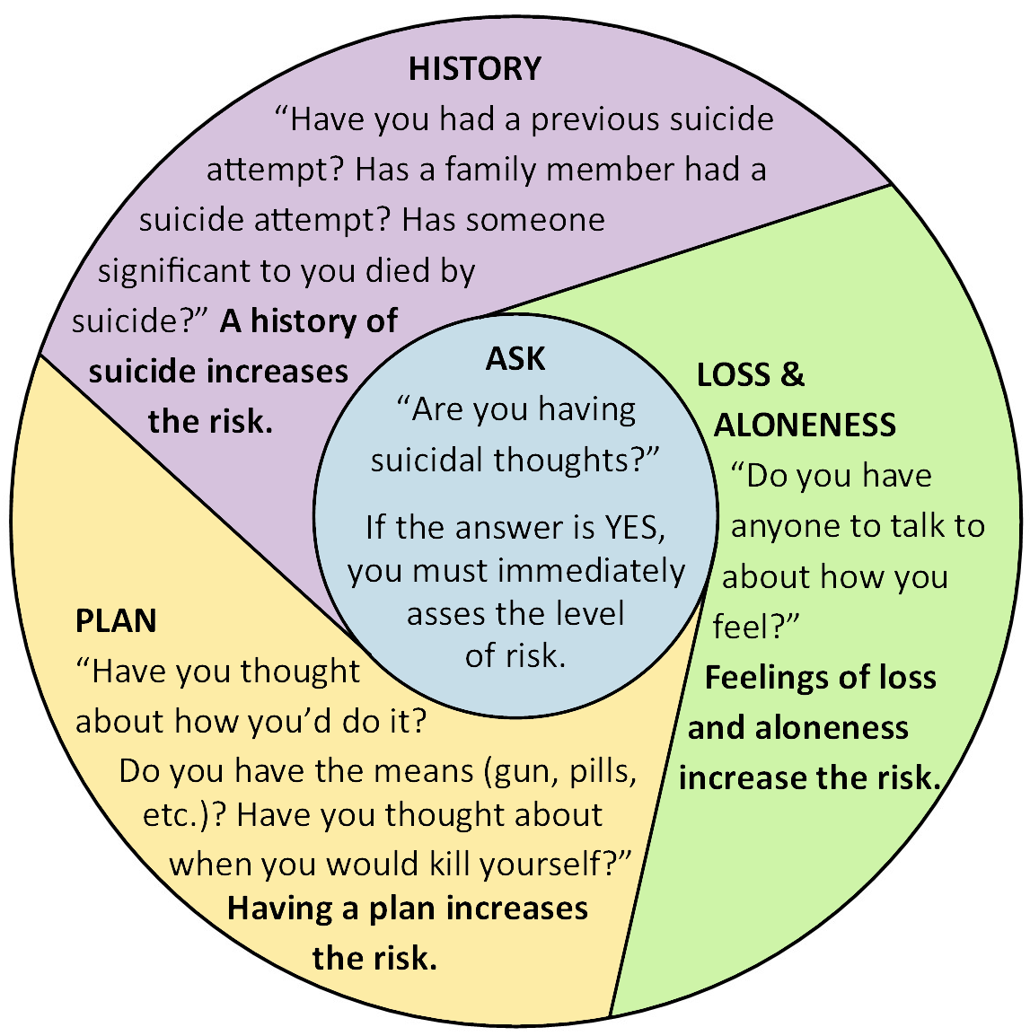
L
P
LOW risk - no H*L*P factor currently present
MEDIUM risk - one H*L*P factor present
HIGH risk - two or more H*L*P factors present

Is Path Warm? – Screening Tool

Suicidal Ideation is a serious warning sign of risk for suicidal behaviours. A history of mental illness or a prior suicide attempt further increases risk.

I  (Ideation) | Warning signs of expressed or communicated ideation include:  - Threatening to, or talking about wanting to hurt or kill self.  - Seeking access to means (i.e. pills, weapons).  - Talking or writing (look at social media) about death, dying, suicide, when these actions are out of the ordinary.
S  (Substance Use) | Increased or excessive substance use
P  (Purposelessness) | No reason for living; no sense of purpose in life.
A  (Anxiety) | Anxiety, agitation, unable to sleep or sleeping all the time
T  (Trapped) | Feeling trapped – like there’s no way out; resistance to help.
H  (Hopelessness) | Hopelessness about the future
W  (Withdrawal) | Withdrawing from friends, family and society.
A  (Anger) | Rage, uncontrolled anger, seeking revenge.
R  (Recklessness) | Acting reckless or engaging in risky activities, seemingly without thinking.
M  (Mood Change) | Dramatic mood changes

6-ITEM Kutcher Adolescent Depression Scale: KADS

NAME: DATE:

OVER THE LAST WEEK, HOW HAVE YOU BEEN “ON AVERAGE” OR “USUALLY” REGARDING THE FOLLOWING

- Low mood, sadness, feeling blah or down, depressed, just can’t be bothered

Hardly ever | Much of the time | Most of the time | All of the time

- Feelings of worthlessness, hopelessness, letting people down, not being a good person
Hardly ever | Much of the time | Most of the time | All of the time

- Feeling tired, feeling fatigued, low in energy, hard to get motivated, have to push to get things done, want to rest or lie down a lot
Hardly ever | Much of the time | Most of the time | All of the time

- Feeling that life is not very much fun, not feeling good when usually would feel good, not getting as much pleasure from fun things as usual
Hardly ever | Much of the time | Most of the time | All of the time

- Feeling worried, nervous, panicky, tense, keyed up, anxious

Hardly ever | Much of the time | Most of the time | All of the time

- Thoughts, plans or actions about suicide or self-harm

Hardly ever | Much of the time | Most of the time | All of the time

TOTAL SCORE:

6-ITEM KADS scoring:

In every item score:

Hardly Ever = 0
Much of the time = 1
Most of the time = 2
All of the time = 3

Then add all 6 item scores to form a single Total Score.

Interpretation of total scores:

Total scores at or above 6 | Suggest ‘possible depression’ (and a need for more thorough assessment).
Total scores below 6 | Indicate ‘probably not depressed’.

Section 2: Safety Plans

Safety Plan #1
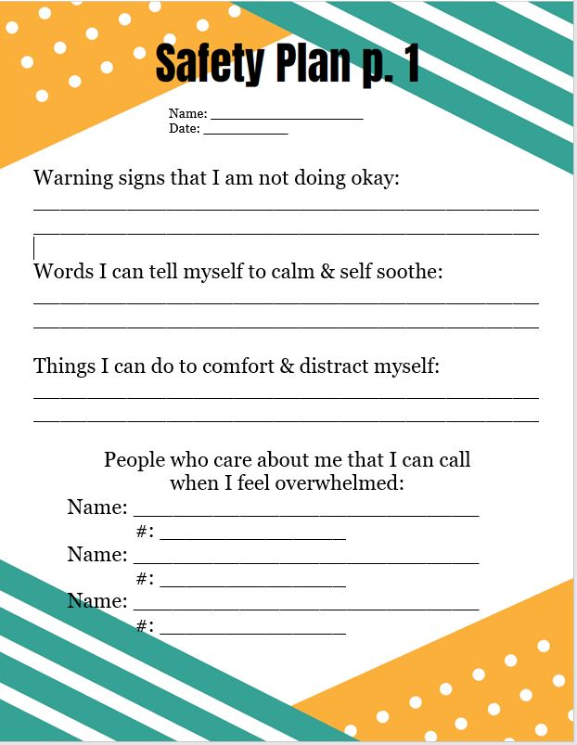

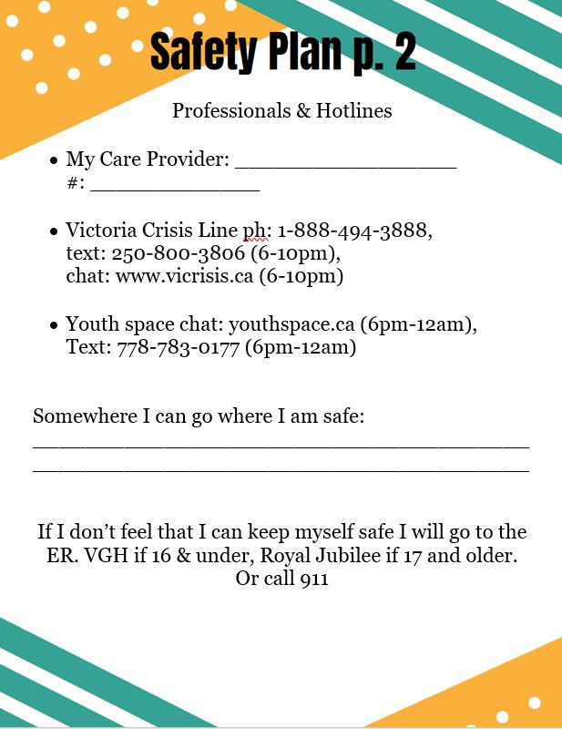

Coping Plan

Name: Date: ,

My coping tools:

How someone could tell I am coping well:

How someone could tell I am not coping well:

How will I communicate when I am not coping well:

If I am not coping well, I will:

Tell/text , if they aren’t available, tell /text
or call crisis line (1-888-494-3888)

I will go somewhere safe: , call 911 or go to the hospital.

Contact Numbers:

Safety Plan #2

Name Date

Things I can do or tell myself to make myself feel better: clinician can assist

People who care about me that I can call when I feel overwhelmed:

NAME RELATIONSHIP NUMBER

Hotline number/s I can call:

AGENCY NUMBER HOURS OF OPERATION

You can always call 911 to ask for help.
Tell the operator you are in suicidal danger.

Online resources:

Section 3: Resources

Community Phone Numbers

- IMCRT Confidential Pager - 250-361-5958 (Do NOT give to families)
Available from 1pm – Midnight for those experiencing mental health and/or addiction crisis. Service is not an alternative to 911 and should be used when there is an urgent need or a concern that the situation may become emergent, or the counsellor wishes to consult. Clients may not self- refer, but can use the Vancouver Island Crisis Line for access. VGH staff requests that counsellors attempt to use IMCRT before going to hospital if it is an appropriate option.

- CYMH High Risk Team - 250-952-5073
Offers support to youth under 19 and is available Mon-Friday 8:30 – 4:30. They are available to consult, and service includes risk assessment, short term treatment, community connection and follow-up. The High Risk Team would prefer to work with youth that do not already have a community service provider in place.
This is not an emergency service. It is an urgent service. Referrals will be responded to within three working days but often contact may occur within one working day.

- Victoria General Hospital
ER Nurse Consult – 250-727-4020/ pager 778-679-3543.
Available for consultation purposes, particularly when IMCRT is not available - 16 years and younger

- Royal Jubilee Hospital - 250-370-8000
Available for consultation purposes
Call Emergency Department and ask for a Social Worker -17 years and older

- Child and Youth Mental Health:
- Saanich CYHM 250-952-5073 x131
- Indigenous CYMH 250 952-4073
- Victoria CYMH 250-356-1123
- West Shore CYHM 250-391-2223

Team Leaders available for consultation Monday through Friday.

- Intake Child Protection – Centralize Screening - 1-800-663-9122
Provides child protection reports, initial requests for ministry support services. Available 24 hours a day.

- Vancouver Island Crisis Centre - 1-888-494-3888
Is the number for families to access the IMCRT Team, and will support youth and families with Crises. See information for text and chat support in chat/text resource section.

District Contacts
District Counselling Team
Available for consultation, but does not replace protocol for informing school admin as stated in protocol.

District Middle Counsellor
Monique Moore - 250-464-1109 mmoore@sd61.bc.ca

District Elementary Counsellor
Maureen von Tigerstrom - 250-893-2509 mvontigerstrom@sd61.bc.ca

District Youth and Family Counsellor
Jen Aston - 250-475-4243 jaston@sd61.bc.ca

Indigenous District Counsellor
Joanne Mitchell - 250-883-2931 jomitchell@sd61.bc.ca

OTHER PHONE NUMBERS

Resources for Youth & Families

Phone, Chat & Text Support:

1. Youthspace.ca Chat: www.youthspace.ca, text: (778) 783-0177
Operates 6pm – midnight, all youth under 30

2. YouthinBC Chat: www.YouthinBC.com, phone: (604) 872-3311
Operates 24/7 crisis phone service, online chat noon – 1 am

3. Kids Help Phone Chat: www.kidshelpphone.ca, phone: 1-800-668-6868
Operates 24/7 crisis phone service, online chat Wed – Sunday 3pm – 11pm

4. Van. Island Crisis Line Chat: www.vicrisis.ca, phone 1-888-494-3888, text: 250-800-3806
Operates 24/7 phone support, chat and text 6pm – 10pm

5. 1-800-SUICIDE Phone: 1-800-784-2433
Operates 24/7

5. Trans Life Phone: 1-877- 330- 6366
Operates 24/7

6. KUU_US Phone: 1-800-588-8717
For Indigenous Youth 24/7

Online Resources:

1. Youthspace Support and information for youth under 30, online chat and text support, a moderated forum, resources and a link to email counselling with Pacific Centre Family Services

2. Kelty Mental Health Mental Health, substance use, and healthy living
Resources for children, youth, families and schools

3. Youth in BC Resources on specific topics including depression, anxiety, suicide, self-injury etc.

4. Mind Check Information, resources, and youth-accessible screening
tools related to mental health and substance use

5. Here to Help Information, support and youth accessible screening tools for mental health, substance use etc.

6. Mind Your Mind Mental health information, support and resources for youth

7. Family Smart Providing parent/caregiver support navigating the mental health system and support finding community resources

Mindfulness Resources:

1. Do Yoga With Me Free online yoga and meditation for all ages

2. Kelty Mental Health Free mindful meditations, stress relievers and body scans available

3. Calm Free and easy online relaxation moments

4. Head Space Guided online meditation. First 10 sessions free

5. Thinkfully Free online resource for relieving stress, problem solving and living well

Mindfulness & Wellness Apps:

1. Breathr Developed by BC Children Kelty Mental Health – Free app provides opportunity to try a variety of mindfulness practices

2. MindShift Developed by Anxiety Canada to provide free CBT resources to help manage anxiety

3. Calm Sleep, meditation and relaxation – lowering stress and anxiety – free resources are available:

4. Insight Timer Free App for sleep, anxiety and stress

Further Community Resources available in Counsellor Corner - Learning Team Website
Password is GVSDCOUNSELLORS or by clicking HERE

OTHER RESOURCES

Articles, Toolkits & General Resources

NEED2 Suicide Prevention Booklets for Youth, Professionals and Families (hard copies in each Suicide binder:
Suicide Prevention Booklet Youth
Suicide Prevention Toolkit Professionals
Suicide Prevention Toolkit Adults
This guide below from the Ministry of Education focuses on Indigenous and LGBTQ2S+youth, self-harming practices, and the role of social media in recognizing and responding to suicidal behaviours:
Guide to Working with Specific Groups of Children and Youth at Risk for Suicide
The BC Public Service’s created the following document to provide applied clinical information for assessing risk in youth. It was developed by Dr. Jennifer White, a subject matter expert on youth suicide prevention, intervention and postvention:
Practice Guidelines for Working with Children and Youth At-Risk for Suicide in Community Mental Health Settings
The following report was released today by the Representative for Children and Youth's Office: Detained: Rights of children and youth under the Mental Health Act. The report give insight into some of the major issues facing kids in our communities:
A Way to Cope Exploring non-suicidal self injury in B.C. youth
Detained: Rights of children and youth under the Mental Health Act
S.E.L.F. Toolkit – Adolescent Version - This toolkit from BC Children’s Hospital was created for adolescents to help them understand what things tend to cause them stress, what stress looks like for them, and what tools they can try to help them feel better. Information from this toolkit can be used to develop a safety plan.

Current Self - Report of Suicide Risk

EVERYTHING IS OK. I’M MAINTAINING

I’VE HAD A ROUGH DAY
SIGNIFICANT LIFE EVENT/STESS. IT MAY TAKE LONGER TO COPE
I’VE BEEN DOWN FOR A WHILE AND I DON’T EXACTLY KNOW WHY

I’M NOT DOING WELL AND I’D LIKE SOMEONE TO KEEP AN EYE ON ME – CHECK IN REGULARLY

I’M IN CRISIS – PLEASE CALL OR COME OVER RIGHT AWAY

CALL 911 – I MAY HURT MYSELF OR OTHERS. DO NOT WAIT.

Hope Boxes
A common approach used to treat people who are depressed and thinking about suicide is to help them identify and remember several reasons for hope and to keep living. One specific intervention often used in cognitive-behavioral therapy (CBT) to cultivate hope is to create a “hope box” (also known as a “crisis kit”), a collection of various items that remind the depressed person that their life is meaningful and worth living.
A hope box is made by getting a box, envelope, bag or any type of container and filling it with reminders of things that give you hope, or that have given you hope in the past. Some people choose to creatively decorate their box, while others keep them plain and simple.
Items in a hope box may include:
- Cards, notes or emails with special meaning
- Photos of special times and places in the past or desired destinations for the future
- Photos of loved ones
- Spiritual verses, prayers or objects, if you are religious
- Recordings of relaxing or uplifting music
- Letters or recordings from loved ones offering positive, caring messages
- Inspiring articles, affirmations, quotes or poems
- Jokes or stories that make you laugh
- Lists of goals, dreams and aspirations
- Coping cards with skills or activities used to cope with stressful situations
- Anything else that reminds you of reasons to stay alive

The person is asked to keep their hope box nearby and use its contents when they feel distressed, depressed or suicidal. The technique helps to address and combat irrational beliefs (e.g., “I am worthless ,” “life isn’t worth living anymore”) that are often associated with depression and suicidal thinking.
By looking at the items in the hope box, the individual can learn to directly challenge and modify these distressing and negative thoughts by being reminded of previous successes, positive experiences, and reasons for living.
It’s often suggested to also put a copy of one’s safety plan in the hope box. The safety plan lists things to do to feel better when depressed or thinking of suicide, people to contact to talk to for support, and contact information for places to call for professional help in a crisis.
It is also recommended to put things in the hope box that can serve as a distraction to negative thoughts. These might include puzzles, playing cards, drawing materials, or other similar items.
The “Virtual Hope Box”

Although the hope box is a helpful tool, it’s sometimes difficult to keep it close at hand. It may be inconvenient to have on a trip or in certain work environments, such as those involving extreme weather or in military or public safety settings.
To address these limitations, the Virtual Hope Box, a free smart phone application (Apple, Android) has been developed which allows someone to keep a virtual collection of their reasons for living close by at all times.
The Virtual Hope Box is designed to be used as an accessory to mental health treatment, with simple tools to help with coping, relaxation, distraction, and positive thinking. It has the same types of items (although in digital form) as the traditional hope box (photos, videos, music, messages from loved ones), plus several more features.

District Suicide Threat Protocol

Suicide

At School
- Check vitals. Call 911 and inform dispatcher that a suicide has taken place.
- Call parents/guardians and inform them that an emergency has taken place. Direct them to go to the school or hospital, as appropriate. Ensure that someone meets them when they arrive.
- Secure the room that the student is in, as it is a crime scene.
- Take any witnesses to a private area to wait for police. Have a staff member with them to provide support.
- Call the Superintendent’s office.
- Wait for police and brief them when they arrive to take over the scene.
- Assemble school-based Critical Incident Team.
- Call District Critical Incident Team.
- Inform staff of the incident and have them contain students in classrooms.

Out Of School
- Inform the Superintendent.
- Meet with the school-based Critical Incident Response Team and plan response.
- Meet with staff to inform them of the death. If possible do this before school starts so that staff have a chance to process the information before going to their classrooms. Provide TOC coverage for staff who are unable to return to their classrooms right away.
- Contact staff who are absent to inform them of the death.
- Call district Critical Incident Team.

All Situations
- Do not talk to the media.
- Contact family. Express sympathy, both personally and on behalf of the school, keeping multicultural sensitivities in mind.
- If possible, with sensitivity clarify with family what details may be shared with the school community and whether the family is referring to the death as a suicide or a sudden death.
- Call close friends of the student out of class to tell them about the death. Contact their parents/guardians immediately so that the students have support at home.
- Prepare a statement to be read to students giving basic facts, but no details, of the death. Unless the parents/guardians give permission to refer to the death as a suicide, call it a sudden death.
- Prepare a letter to go home to parents/guardians, informing them of the sudden death, outlining support provided by the school and ways that they can support their children.
- Develop a plan for immediate and follow-up support for students and staff. It is likely that district and/or community support will be needed to deal with a suicide due to the magnitude of its impact. Contacting these supports and engaging their assistance quickly will be beneficial. The District Critical Incident Team, Project Alive, and Living and Learning through Loss can provide support.
- Prepare a list of students who might be at risk of suicide and contact parents/guardians, if appropriate.
- Organize a drop-in centre for students.
- Monitor social networking sites (Facebook, etc.), if possible.
- Hold a staff meeting at the end of the day. Assess staff needs.
- Ensure documentation is complete.
- Inform staff and students of funeral arrangements.
- Consider holding a memory event as you would for any death in order to gather as a school community, honour the life of the student, and begin the transition to normal life.
- Following the funeral, have school return to normal routines. Continue to monitor student reaction (particularly students identified as at-risk for suicide) and connect vulnerable students with community resources.
- Monitor student reaction on anniversaries of the suicide and provide support, as necessary.
- Direct staff members to remove student’s name from computer, attendance and mailing lists.
- Involve family and/or close peers of the deceased in the plan for clearing the student’s locker, desk and personal effects.

NOTE: FOLLOWING A SUICIDE, OR A SUDDEN DEATH, STUDENTS MAY BE MORE VULNERABLE TO SUICIDE ATTEMPTS, PARTICULARLY ON ANNIVERSARIES.

Suicide Attempt

(The student has the means to carry out the suicide right there.)
- Administer first aid, if required.
- Call 911, inform the dispatcher that it is a suicide attempt, and ask for the Emergency Mental Health Services Team, if available. Have someone meet police/ambulance and escort them to the student. The student will be taken to the hospital by ambulance for a mental health assessment.
- Identify a key staff member who has positive connections with the student and have them remain with the student to provide support.
- Contact the parents/guardians (and/or social worker, if involved).
- Clear non-essential personnel from the area or move the student to a safe area.
- Inform the Associate Superintendent.
- Consult with the police when they arrive to take charge of the scene.
- Assemble school Critical Incident Team.
- Inform staff members and debrief at the end of the day.
- Plan for and provide support to classmates and school-population, as appropriate.
- Identify other students who may be at risk for suicide and monitor their behaviour. Monitor social networking sites (Facebook, etc.) if possible.
- Connect parents/guardians with appropriate community resources, if appropriate.
- Ensure that a written record of the attempt is kept in the student's file and that this information is given to the receiving school immediately should the student transfer.
- Develop a safety plan with parents/guardians, students, counsellor and key staff to address the student's needs when returning to school after hospitalization or treatment.
- Continue to monitor the student for changes in appearance, attitude, academic performance or behaviour, which might signal an increase of risk. Provide ongoing support.
- Do not compromise your own personal safety if a weapon is involved.
- Do not leave the student alone until police or ambulance personnel take control.
- Do not allow bystanders to view the event.
- Do not bring other students to talk to the person attempting suicide.

NOTE: FOLLOWING A SUICIDE OR A SUDDEN DEATH,
STUDENTS MAY BE MORE VULNERABLE TO SUICIDE ATTEMPT.

Suicide Threat - Student

(The student is talking about a future suicide.)
- Identify a key person who has positive connections with the student.
- Have that key person talk to the student to determine seriousness of the RISK. (Lethality, availability and short timeframe). The more lethal and available the means, and the more definite the timeframe, the greater the risk.
- School personnel should contact the Emergency Mental Health Team through their confidential pager number at 250-361-5958.
- Inform parents or guardian, if appropriate, and direct them to come to the school to meet with you and pick up the student.
- Connect student and/or family with community resources, (Project Alive), as appropriate.
- Ensure that the school counsellor, if not already involved, is informed.
- Review student's history to determine whether previous threats/attempts were made.
- Inform principal.
- Ensure a written record of this threat is kept in the student's / IEP file and that this information is given to the receiving school immediately if the student transfers. If threat is serious, develop a safety plan outlining supports in place.
- Continue to monitor the student for changes in appearance, attitude, academic performance or behaviour, which might signal an increase of risk and provide ongoing support

Resources for Younger Students

Children and Suicide - This guide from the Centre for Suicide Prevention provides an introduction to the topic of children and suicide. It includes statistics, warning signs, ideas to consider when talking to a child about suicide, risk factors, protective factors, ways suicide in children can be prevented and additional resources.

https://www.suicideinfo.ca/resource/children-and-suicide/

Talking to Children About a Suicide - This resource from the Mental Health Commission of Canada is designed to help adults have supportive conversations with children under 12 who have experienced the loss of a family or community member to suicide.

https://www.mentalhealthcommission.ca/sites/default/files/2021-03/talking_to_children_about_a_suicide_eng.pdf

S.E.L.F. Toolkit – Kid’s Version - This toolkit from BC Children’s Hospital is a package full of visuals to guide children through the process of identifying stressors, warning signs, and tools to feel better so that a meaningful safety plan can be collaboratively developed.

https://keltymentalhealth.ca/sites/default/files/resources/SELF%20Toolkit%20for%20Kids.pdf

My Safety Plan

Name:_____________________________ Date:______________________________

STEP 1:
Do one or more of these things to calm/comfort myself:

STEP 2:
Remind myself of my reasons for living/things I look forward to:

STEP 3:
Talk to a family member or friend and a trusted adult:

At home:

At school:

Kids Help Phone: 1-800-668-6868
Vancouver Island Crisis Line: 1-888-494-3888
In an emergency: 911

Visual Mood Scale

Name:_________________________ Date:______________

How are you feeling in this moment?

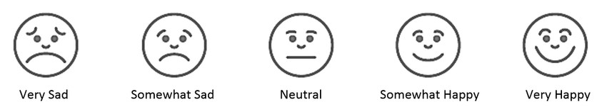

How have you been feeling over the past few days?

How have you been feeling over the past few weeks?

Visual Mood Scale (With Number Scale)

Name:_________________________ Date:______________

How are you feeling in this moment?

1 2 3 4 5

How have you been feeling over the past few days?

1 2 3 4 5

How have you been feeling over the past few weeks?

1 2 3 4 5

Resources for Students with Indigenous Ancestry

First Nations Health Authority: Hope Help and Healing: A Planning Toolkit for First Nations and Aboriginal Communities to Prevent and Respond to Suicide

KUU-US Crisis Line Society
First Nations and Aboriginal specific 24/7 crisis line based in Port Alberni and serving the entire province. Toll-free: 1-800-588-8717 - Youth Line: 250-723-2040 - Adult Line: 250-723-4050.

Native Youth Crisis Hotline -1-877-209-1266 Answered by staff 24/7 Available throughout Canada and US.

Mental Health Information Line 310-6789 (no area code needed)
Answered 24/7/365 it provides empowering emotional support, information on appropriate referral options and a wide range of support relating to mental health concerns.
See the Here to Help website for more information

A complete list of all crisis line numbers in BC

